Discovering Shandong Art and Culture China in the Dimension of Wisdom, Beliefs, Traditional Ways of Life and Festivals
Kai Zhang, Rosjana Chandhasa

Abstract

With the country's continued emphasis on industry, culture and creativity industry, the cultural and creative industries on the university campus have demonstrated a strong drive of development. Shandong is a famous cultural city with a rich history with a rich material cultural heritage that is constantly inspiring for the cultural and creative industries on the university campus. This study starts from the cultural dimension of wisdom, faith, traditional way of life, and festivals and uses qualitative research methods. With a descriptive and analytical method, to explore the cultural and artistic information learning area of Shandong Province. Through comprehensive analysis and data collection, we skillfully integrate these cultural elements into the design of souvenir products, and contribute to the promotion of Shandong culture and the creation of unique cultural and creative products.

The results showed that the study of information on Shandong arts and culture In the wisdom dimension The profound Confucian tradition of Shandong Province injected a unique humanistic spirit into its culture and art, which is not only reflected in the daily life philosophy of the Shandong people, but also the culture of Shandong people. In the belief dimension, Shandong province's religious and folk beliefs provide a wide area for art development, which not only strengthens the connotation of art, but also makes them more regional and cultural. In the lifestyle dimension Shandong province's unique living traditions and farming culture provide valuable materials for art development. By delving deeper into these elements, it is possible to design souvenirs with more regional characteristics and cultural values, and the traditional festival dimension. The Spring Festival and Zhoucun Xinzi Festival are not only the spiritual sustenance factor of Shandong people. Using these elements of festivals, art can be developed at a strong cultural atmosphere to meet people's pursuit of a better life. Based on the findings, it leads to strong support and guidance for the cultural and creative industry in Shandong Province, and helps promote the development of souvenir products in Shandong University.

Keywords: Arts and culture, Lifestyle, Wisdom, Beliefs, Festivals.

Introduction
The purpose of this article is to explore how to draw inspiration from the dimension of wisdom. To design souvenirs with regional cultural characteristics for universities in Shandong Province. Based on an in-depth analysis of Shandong's rich historical and cultural heritage, this article proposes design ideas that combine Confucian wisdom, religious beliefs, unique lifestyles and elements of traditional festivals. This innovative approach aims to create souvenirs that inherit the essence of Shandong culture and meet the needs of modern aesthetics. The author also discusses how to skillfully integrate these cultural elements into product design, and how to effectively promote and spread Shandong culture through university souvenirs. This study has important theoretical and practical significance in promoting the development of cultural and creative industries in Shandong Province and strengthening the cultural brand image of the university. It is hoped that through the exchange and discussion of this international conference, it can provide new ideas and inspiration for the design and development of souvenirs in Shandong University, and promote the dissemination and exchange of Shandong culture in the international arena. The main goal of this study is to explore the souvenir design direction in Shandong University, especially to find cultural inspiration and position in the four cultural dimensions of wisdom, faith, traditional lifestyle and festival, and to precisely capture the unique charm and spiritual core of Shandong culture through in-depth research in these dimensions, to provide strong cultural support and creative inspiration for the university's souvenir design.

Research Objectives
To discover Shandong arts and culture in terms of wisdom, beliefs, traditional ways of life and festivals.
Literature Review
Research status in the country
In recent years, domestic scholars have conducted in-depth research on the relationship between Shandong culture and souvenir design in Shandong University by It mainly focuses on Confucian wisdom, folk beliefs, traditional festivals and ways of life. These studies provide great support for the design and development of souvenirs in Shandong University, and also provide valuable references for future research.
In terms of wisdom, Professor Li Ming has deeply analyzed the importance of culture. Qilu towards souvenir design in colleges and universities in Shandong Province in the article "Research on Qilu culture and university souvenir design" and put forward strategies for integrating the wisdom of Confucian culture and culture. Qi matches the design. The conclusions of the study suggest that Qilu culture, as the cultural soul of Shandong Province, provides many materials and inspiration for designing souvenirs in colleges and universities.
In terms of traditional festivals. Professor Zhang Hua focused on the enlightenment of traditional festivals in Shandong Province, such as Spring Festival and Mid-Autumn Festival, in the article "Application of Shandong Traditional Festival Elements in Souvenir Design in Colleges and Universities". This study outlines how to apply innovative elements of traditional festive elements to souvenir design and highlights the importance of festive atmosphere and cultural connotations.
In terms of faith, Professor Wang Yong's "Research on the Application of Qilu Faith Culture in Souvenir Design" focuses on analyzing the influence of belief culture on souvenir design. Point out that Shandong's folk beliefs and religious culture provide perspective and inspiration for unique souvenir designs. Digging deeper into these elements of faith makes it possible to design more unique souvenirs of the region and cultural heritage.
In terms of the traditional way of life. Dr. Wang Hong deeply analyzed the influence of Shandong people's living habits and cultural traditions on souvenir design from the perspective of lifestyle in "Souvenir Design Research in Shandong University from the Perspective of Lifestyle". This study presents the idea of inclusion.
International Research Status
At the international level, scholars are also interested in studying university souvenirs based on wisdom, faith, lifestyle and traditional festivals.
In "Wisdom in Design: Incorporating Intellectual Heritage into Campus Merchandise," Professor David Lee delved into the application of wisdom elements in campus souvenir design. Studies argue that by combining the academic and historical wisdom of a university, souvenirs can provide a deeper cultural connotation and educational significance.
In The Role of Traditional Beliefs in Campus Merchandise Design, Dr. Johnson delves into the value of traditional beliefs in campus souvenir design. He believes that incorporating clever faith elements into design can make souvenirs have a deeper cultural meaning. This will help increase the emotional connection with consumers.
In his article "Lifestyle Trends and Their Impact on Collegiate Merchandise", Professor Lee analyzed the impact of lifestyle changes on university souvenir design. She pointed out that with the diversity of student lifestyles, the university's souvenir design also needs to be constantly innovated to meet the aesthetic and practical needs of different students.
In his article "Campus Souvenirs: Reflecting Culture and Tradition," Professor Smith discusses how to blend campus culture with traditional festivals to design campus memorabilia. The study emphasizes the importance of traditional festivals in the design of university souvenirs and proposes strategies for incorporating the cultural elements of the university in the design.
From both domestic and international research, it can be seen that both domestic and international scholars generally believe that wisdom, faith, lifestyle, and traditional festivals are the main sources of inspiration for the design of university souvenirs. These elements not only help preserve and promote the university's culture, but also enhance the sense of belonging and identity of students on campus. In the future, with deeper research and practical development, the university's souvenir design will pay more attention to culture, innovation and practice, and become an important service provider for the inheritance and development of the university's culture.
Research Methodology
Qualitative research methods are used to explore the application of cultural dimensions such as wisdom, faith, lifestyle, and traditional festivals in souvenir design in Shandong University. The researcher summarized the steps as follows:
Step 1: Look for a cultural dimension First, the main cultural dimensions of the study, namely wisdom, faith, traditional lifestyles and festivals, have been identified and defined, and the meanings and characteristics of these cultural dimensions have been explored deeply through literature reviews, expert interviews, and field investigations, and their specific symptoms in Shandong culture have been identified.
Step 2: Data Collection At the data collection stage, questionnaires, in-depth interviews and observation methods are used. Extensive surveys were conducted among Shandong University's students, faculty, and local residents to understand and realize these cultural dimensions. At the same time, we have also collected historical documents, artworks and other materials related to Shandong culture to add our resources.
Data collection is an important step in the study of searching for university souvenirs based on wisdom. To ensure the comprehensiveness and accuracy of the data, the authors used a variety of data collection methods. Through literary research, the author has studied books and articles on culture, history, culture, and culture. To understand the connotation and deep expression of wisdom. Shandong traditional beliefs, lifestyles and festivals, In-depth interviews, through in-depth exchanges with students, faculty, staff, and local residents on campus, learn about their understanding and practices of wisdom, faith, lifestyle, and traditional festivals, as well as the design of the university memorabilia they have been waiting for. and field surveys. Visit every corner of the campus to observe and record specific symptoms of campus culture. At the same time, we also visited cultural sites and local museums to learn more about local history and cultural traditions.
Step 3: Data analysis In the data analysis phase, we use content analysis, theme analysis, and other methods to carry out in-depth interpretation and analyze the collected data, focusing on cultural characteristics, values, and behavioral patterns reflected in the data, and trying to draw conclusions that provide recommendations for souvenir design in Shandong University.
Step 4: Summarize the results and analyze the results using data After completing the data analysis, the results of the study are summarized and compiled into a detailed report. The report includes an in-depth analysis of various cultural dimensions, presentation of data results, and recommendations for souvenir design in Shandong University, and returns these results to the design team and relevant decision makers. To provide useful references and inspiration for their design work. To analyze the collected data comprehensively and deeply, we use a variety of methods such as descriptive statistical analysis, content analysis, factor analysis, and correlation analysis. Through literary research and in-depth interviews, we found that Shandong wisdom is mainly reflected in the inheritance and practice of Confucian culture. As one of the cradles of Confucianism, Shandong's wisdom system emphasizes values such as benevolence, courtesy and loyalty. In university culture, these elements of wisdom are inherited and passed on and become an important force in shaping the character and moral values of students., Belief Analysis In terms of faith, Confucianism is mainstream in Shandong Province, supplemented by Taoism, Buddhism and other diverse beliefs. These beliefs occupy an important place in Shandong culture, influencing the lifestyle, values and behavioral norms of local residents. In the design of university souvenirs, these belief elements can be integrated to enhance the cultural connotation and spiritual value of souvenirs, lifestyle analysis. Through questionnaires and field trips, we learned that the lifestyle of students in Shandong College and University has strong regional characteristics. They pay attention to family values, value etiquette traditions, and embody love and respect for traditional culture in their daily lives. These lifestyle attributes are a source of inspiration for university souvenir design, such as designing souvenirs with a family atmosphere and focusing on etiquette norms, and analyzing traditional festivals. These festivals have a deep historical and cultural heritage and national feeling, and have become an important time for local residents to celebrate and reunite. In the design of university souvenirs Traditional festive elements can be used, such as festival-themed souvenir designs. Combining symbols and traditions of festivals, etc., to enhance the cultural identity and emotional value of souvenirs.
Through the analysis of this data, an in-depth understanding of the wisdom, beliefs, lifestyle, and traditional festivals of Shandong culture was obtained. These cultural elements not only have diverse connotations and unique charms, but they also provide valuable creative inspiration for campus souvenir designs. In the design of future university souvenirs, one should fully consider the characteristics of Shandong culture and skillfully combine elements such as wisdom, faith, lifestyle and traditional festivals with the design to create souvenirs that not only have cultural meaning, but also satisfy the aesthetics of young people.
Research Results
From the search results of Shandong city arts and culture in the dimension of wisdom, beliefs, traditional ways of life and festivals to explore how they influenced and inspired the design of university souvenirs. From the collection and analysis of the data, it was found that:

Table 1 Wisdom Analysis Results
Order | Wisdom Dimension Culture Products | Definition of Wisdom Dimension
1. | 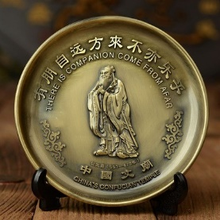 | Application and importance of aphorisms of famous historical celebrities in Shandong Province For example, the classic sentences of Confucius are an important part of Shandong wisdom. "Make friends from afar," "Revisit the old and learn the new," etc. These sentences can be used as decorative elements for souvenirs, and consumers can see these classic sentences at any time when using these souvenirs.
2. | 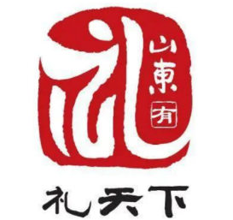 | Application and importance of symbolic forms of Shandong Qilu culture, such as heart-shaped motifs of "benevolence", motifs of ancient ceremonial objects of "rituals", etc. These patterns can be used as design elements for souvenirs, which will make souvenirs more cultural and artistic.
3. | 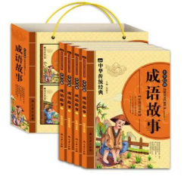 | Application and importance of allusions to Shandong culture Idiomatic stories such as "One Kuang Tianxia" and "One Blockbuster", these historical stories can be used as souvenir design themes.
4. | 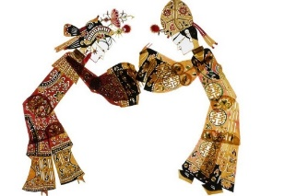 | The application and importance of Shandong cultural and moral concepts, including benevolence, courtesy, loyalty, etc., can be used as the main concept of souvenir design, to remind people to pay attention to etiquette and civilized interaction in social situations.
Source: Author
From Table 1, it is found that the main elements of Shandong wisdom are widely and deeply applied in souvenir design. With the use of classic sentences, symbolic forms, historical figures and stories, moral concepts and other elements. Wisely, the wisdom of Shandong Province is combined with the design of souvenirs to give souvenirs a cultural connotation and practical value. Such designs can not only satisfy the needs and preferences of consumers. But it also inherits and perpetuates the wonderful traditional culture and wisdom connotation of Shandong Province.

Table 2 Belief Analysis Results
Order | Products Culture Dimension Belief | Definition of Belief Dimension
1. | 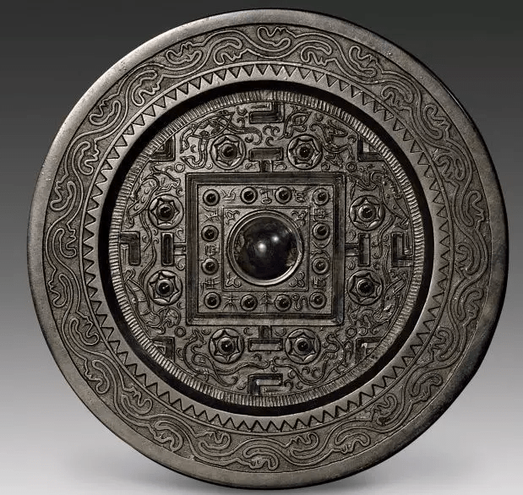 | Application and importance of heaven and earth worship: The worship of heaven and earth represents people's reverence and gratitude for the nature of heaven and earth. In the design of university souvenirs Elements of heaven and earth worship, such as jewelry or ornaments inspired by the "round sky," can be used to express gratitude for the school's cultivated grace.
2. | 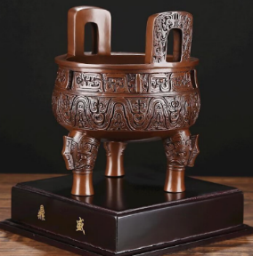 | Application and importance of ancestor sacrifice: Ancestor sacrifice is an important part of belief in Shandong Province, which reflects respect and remembrance of ancestors. In the design of university souvenirs It can incorporate elements of ancestral sacrifice to show respect and inherit the history of the school.
3. | 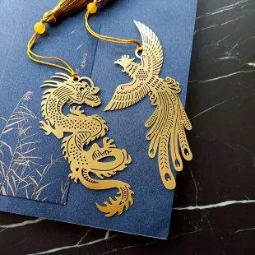 | Application and importance of belief in gods: Belief in gods occupies an important position in Shandong beliefs, reflecting people's worship and prayer for mystical powers. In the design of university souvenirs, images of animals or mysterious symbols from myths and legends can be used as design elements to express wishes and expectations for a bright future for the school.
4. | 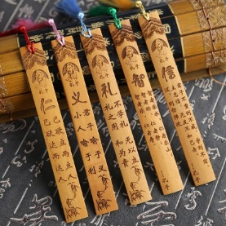 | Application and importance of moral and ethical concepts: The moral and ethical concepts of Confucius are one of the main contents of belief in Shandong Province. In the design of university souvenirs, these moral and ethical concepts can be used as design inspiration to promote the concept of education and moral education of the school.
Source: Author
From Table 2, it can be skillfully integrated elements of Shandong belief into the design of university souvenirs, starting from the dimensions of heaven and earth worship, ancestor sacrifice, belief in gods, and moral and ethical concepts. These campus souvenirs have a faith dimension, not only enriching the cultural life of the campus, increasing the sense of belonging and identity of the students in the school, but also inheriting and promoting the traditional culture and belief system of Shandong Province. Therefore, it is of great importance to pay attention to the application of the dimension of Shandong belief in the development of university souvenirs.

Table 3 Lifestyle Analysis Results
Order | Products Culture, Dimension, Lifestyle | Definition of lifestyle dimension
1. | 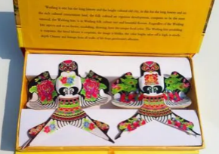 | Combination and application of traditional crafts and handicrafts and their significance: From Shandong traditional crafts combined with modern design elements, we create souvenirs with a unique charm. For example, Weifang kites are a traditional handicraft in Shandong Province, with strong local characteristics.
2. |  | Application and importance of home life and daily necessities: This product combines Shandong cultural elements with daily necessities such as tea sets. Tableware Not only are they practical, but they also add a cultural touch to the home environment.
3. | 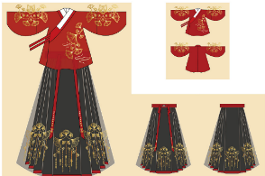 | Application and importance of clothing and accessories: Clothing culture also offers a variety of materials for cultural and creative products. Combining the elements of traditional Shandong clothing with modern design ideas, you can create clothes, shoes, hats, accessories, etc.
4. | 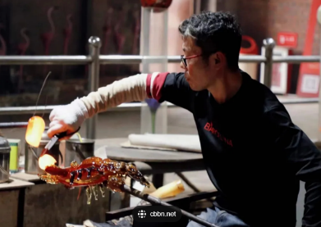 | Application and importance of special food and beverage: Shandong has a deep food culture, so the cultural products and creativity of food and beverage are relatively rich. Zibo enamel souvenirs, beer souvenirs, Tsingtao, etc., all take ingredients or drinks with Shandong characteristics, and transform them into products with cultural connotations through creative design.
Source: Author
From Table 3, it is found that cultural design and creativity in the lifestyle dimension are important reference for cultural and creative products of the university. By painting traditional crafts and crafts, home life and the use of daily necessities, combined with the culture of the university and the needs of students, we can design cultural and creative products of the university that have cultural connotations and are practical and beautiful, and play a positive role in the inheritance and innovation of campus culture.
Table 4 Results of the analysis of traditional festivals
Order | Traditional festival culture products | Traditional festival dimension meaning
1. | 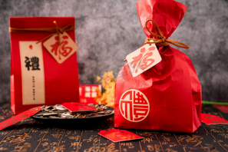 | Application and importance of festive-themed souvenirs: Festival products are usually based on traditional festival themes, combined with traditional patterns, colors, and other elements to create souvenirs with festival characteristics. For example, Spring Festival Greeting Pendant, Festival Lantern Lantern. Dragon boat models of the Dragon Boat Festival, etc. These products are both decorative and can make people feel the charm of traditional culture in a festive atmosphere.
2. | 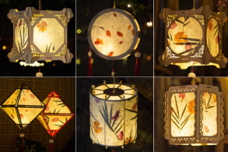 | Celebration and entertainment Usage, and Significance: These festivals are often accompanied by a variety of celebrations and entertainment. For example, during the Lantern Festival. People hang lanterns, guess lantern puzzles, and eat lantern festivals, creating a fun and peaceful atmosphere.
3. |  | Love and marriage Application & Meaning: Holidays are often associated with love and marriage. Qixi Festival is Valentine's Day in China, and legend has it that it is the day when herds of cows and weaving girls meet, and people show their love for their loved ones on this day, which has a strong color of love and marriage.
4. | 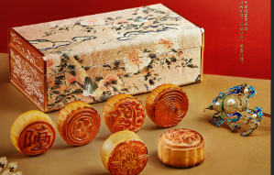 | Application and the importance of reunion and thanksgiving: This holiday emphasizes family reunion and gratitude. The Mid-Autumn Festival is a common gathering festival, where people admire the moon, eat mooncakes, and spend time with their families, while the Chung Yeung Festival emphasizes respect for the elderly, and people climb high to look into the distance.
Source: Author
According to Table 4, Chinese traditional festivals are treasures of Chinese culture, enriching people's lives with cultural connotations and unique ways of celebration, and also providing inspiration and motivation for the continuous development of the cultural and creative industries. Promoting and inheriting these festival cultures on campus not only boosts students' cultural self-confidence and national identity, but also reinvigorates the campus's industrial, cultural, and creative development.
Conclusions
Summary of research results on the search for Shandong arts and culture in the wisdom dimension Traditional beliefs, lifestyles and festivals are classified into 4 dimensions as follows:
Shandong Art and Culture in Wisdom Dimension In conclusion, the research finds that Shandong art and culture in the dimension of wisdom have a great impact on the culture of the university. On the one hand, Shandong's deep artistic heritage and rich cultural resources are valuable materials and inspiration for building the university's culture, making the campus an important position to inherit and promote Shandong culture. On the other hand, the campus has become an important platform to promote the innovative development of arts and culture in Shandong Province, resulting in many artistic achievements with local characteristics. in conclusion Shandong arts and culture in the dimension of wisdom play a positive role in promoting the culture of Shandong University in the dimension of belief. In conclusion, the findings revealed that it plays an important role in the cultural creativity of universities. Shandong's rich cultural and artistic resources, such as Taishan Shi Dangdang and Tao of Confucius and Mencius, are profound cultural soils for cultural creativity on campus. These cultural resources have been creatively transformed into unique university cultural symbols. At the same time, Shandong cultural beliefs such as Confucianism and Qi culture also deeply affect the direction and style of cultural creativity of the university, giving the university's cultural creativity more local characteristics and cultural heritage. Therefore, it is of great importance to delve deeper into Shandong culture, arts and cultural beliefs to promote the development of cultural creativity of the university and improve the quality of culture on campus.
Shandong Art and Culture in Lifestyle Dimension In conclusion, the research finds that the art and culture of Shandong Province are closely related to the lifestyle of the local people and influence each other. Firstly, Shandong art styles such as Lupai Inner Painting, Taishan Stone Dare Dang, Weifang Kite, etc., are deeply influenced by the local way of life, which reflects the aesthetic taste and lifestyle habits of Shandong people. Secondly, these arts and cultures have shaped the Shandong way of life, for example, kite culture has promoted the popularity of outdoor activities, while traditional handicrafts have cultivated people's hands-on ability and innovative spirit. In addition, with the change of modern lifestyle, Shandong art and culture are constantly innovating and developing to adapt and lead to the trend of modern life. In summary, there is a close interaction between Shandong art and culture and lifestyle, which together form Shandong's unique regional cultural landscape.
Shandong Art and Culture in Traditional Festival Dimension In conclusion, the results of the research showed that traditional festivals and arts and culture in Shandong Province are combined and jointly create a rich and colorful cultural atmosphere. These festivals are not only an integral part of the spiritual and cultural life of Shandong people, but also provide many materials and inspiration for the cultural and creative products of the campus. Combined with the cultural and creative products of Shandong Traditional Festival Arts and Culture Campus, it can be inherited and promoted on campus, and the understanding and sense of identity of traditional culture of students are improved. Therefore, the study of Shandong Province art and culture in the dimension of traditional festivals is of great importance in promoting the development of cultural and creative products of the university.
Acknowledgement
Researcher would like to express his sincere to the thesis advisor, Assoc. Prof. Dr. Rosjana Chandhasa for her invaluable help and constant encouragement throughout the course of this research. In addition, the researcher gratefully thanks to Miss Kanyanee Phuangsua, Miss Sasanant Rattanapornpisit, Miss Visitha Chintaladdha, Mr. Chat Sukarin, and others who give great supports.
Finally, the researcher would like to express his gratitude to the Faculty of Fine and Applied Arts, Suan Sunandha Rajabhat University for supporting in every aspect
References
Abbas, M., Jam, F. A., & Khan, T. I. (2024). Is it harmful or helpful? Examining the causes and consequences of generative AI usage among university students. International Journal of Educational Technology in Higher Education, 21(1), 10.
Ahmed, I., Farooq, W., & Khan, T. I. (2021). Customers’ Perceptions and their Responses to Objectives of Islamic Banks–A Three-Wave Investigation. Asian Economic and Financial Review, 11(1), 43. al politics and job outcomes.
Chen, H., Chen, B., & Xu, H. (2012). Economic Research on the Development of Cultural and Creative Industries. Beijing: Economic Science Press.
Donald, A. (2005). Norman. Emotional Design. Beijing: Industry Press.
Iqbal Khan, T., Kaewsaeng-on, R., Hassan Zia, M., Ahmed, S., & Khan, A. Z. (2020). Perceived organizational politics and age, interactive effects on job outcomes. SAGE Open, 10(3), 2158244020936989.
Jamil, R. A., Qayyum, U., ul Hassan, S. R., & Khan, T. I. (2023). Impact of social media influencers on consumers' well-being and purchase intention: a TikTok perspective. European Journal of Management and Business Economics, (ahead-of-print).
Jesse James Garrett. (2011). User-centered Product Design Beijing: China Machine Press.
Jiang, L. (2016). Application of traditional Elements in Cultural and creative product Design Industrial Design, 127. DOI: 10.3969/j.issn.1672-7053.2016.12.057
Li, H. X., Hassan, K., Malik, H. A., Anuar, M. M., Khan, T. I., & Yaacob, M. R. (2022). Impulsive and compulsive buying tendencies and consumer resistance to digital innovations: the moderating role of perceived threat of COVID-19. Frontiers in Psychology, 13, 912051.
Mushtaq, R., Jabeen, R., Begum, S., Khan, A., & Khan, T. (2021). Expanded job scope model and turnover intentions: A moderated mediation model of Core-Self Evaluation and job involvement. Management Science Letters, 11(5), 1473-1480.
Ping, H., Zhang, M., He, H., & Zhang, C. (2017). Research on Campus cultural Creative Product design - A case study of Jilin Jianzhu University. Science and Technology, 255256. DOI:10.16661/j.cnki.1672-3791.2017.26.255
Ren, F. (2016). Research and Practice of Campus Cultural Product design: A case study of ILOVESISO Series Cultural and creative design Art Education Research, 42-44.DOI: 10.3969/j.issn.1674-9286.2016.16.032
Sarwat, N., Ali, R., & Khan, T. I. (2021). Challenging, hindering job demands and psychological well-being: The mediating role of stress-related presenteeism. Research Journal of Social Sciences and Economics Review, 2(1), 135-143.
Tang, J., & Cui, Z. (2017).Design and exploration of creative products of campus culture Journal of Qiqihar University, 147-149. DOI:10.3969/j.issn.1008-2638.2017.08.040
Wang, Q. (2016). Some thoughts on the transmission of local characteristics and national culture in cultural and creative design. Popular Literature and Art.252 DOI:10.3969/j.issn.1007-5828.2016.22.210
Zhang, D., Liu, W., Yu, S., & Shi, J. (2017). Current situation analysis and innovation strategy of university cultural and creative products. China Strategic Emerging Industries, 145-148. DOI:10.19474/j.cnki.10-1156/f.001286
Zhu, P. (2018). Research on Innovation and development path of cultural and creative products in Universities. Journal of Nanjing University of the Arts (Fine Arts and Design)., 151-154.DOI:10.3969/j.issn.1008-9675.2018.04.027

Doctoral Student of Philosophy Program in Visual Arts and Design, Faculty of Fine and Applied Arts, Suan Sunandha Rajabhat University, E-mail: s63584948017@ssru.ac.th
Advisor in Visual Arts and Design, Faculty of Fine and Applied Arts, Suan Sunandha Rajabhat University, E-mail: rosjana.ch@ssru.ac.th.

